**CI/CD Pipeline – GITLAB + Docker**

**Create account gitlab.com – Free!**

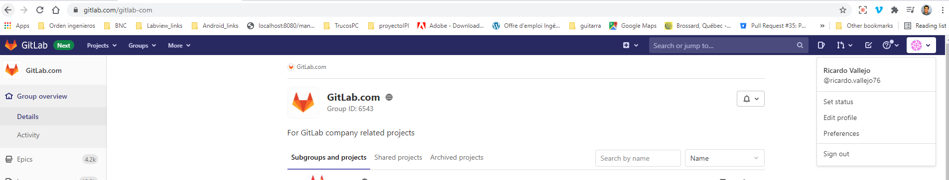

1. Install git

google : git-scm

Verify with: git –version

git config –global user.name “gitlabuser”

git config –global user.email “gitlabuse#gmail.com.com”

git config –global –list

1. Create a new Project Demo

In the root folder of Project

git init

git add .

git status

git commit -m “Second commit”

git push -u “<https://gitlab.com/ricardo.vallejo76/firstgitlabproject.git>” master

**GitLab: understanding pipelines, stages, jobs and organising them efficiently**

<https://medium.com/@ryzmen/gitlab-fast-pipelines-stages-jobs-c51c829b9aa1>

**Hello World Python Gitlab pipeline**<https://dev.to/realedwintorres/create-a-ci-cd-pipeline-in-minutes-with-gitlab-4ll4>  
<https://www.section.io/engineering-education/building-a-cicd-pipeline-using-gitlab/>

.gitlab.ci.yml

image: python:latest

job0:

stage: build

script:

- echo "build phase..."

- uname -a

job1:

stage: test

script:

- echo "test phase..."

- python helloworld.py

job2:

stage: deploy

script:

- echo "deploy phase..."

**Hello World Docker Python Gitlab pipeline**

<https://www.tutorialkart.com/docker/docker-image-with-python-application-example/#:~:text=%20%20%201%20Create%20a%20directory%0AA%20separate,Image...%205%20Check%20the%20docker%20image%20More%20>

variables:

example: this is an example variable

stages:

- stage1

- stage2

build:

stage: stage1

script:

- echo "We are currently in stage 1"

- echo "These are the contents of test.py"

- cat test.py

- echo $example

test:

stage: stage2

script:

- echo "We are currently in stage 2"

- echo "running python script"

- python3 test.py

**Dockerfile**

FROM python

COPY . /src

CMD ["python", "/src/test2.py"]

https://gitlab.com/ricardo.vallejo76/firstgitlabproject/-/pipelines

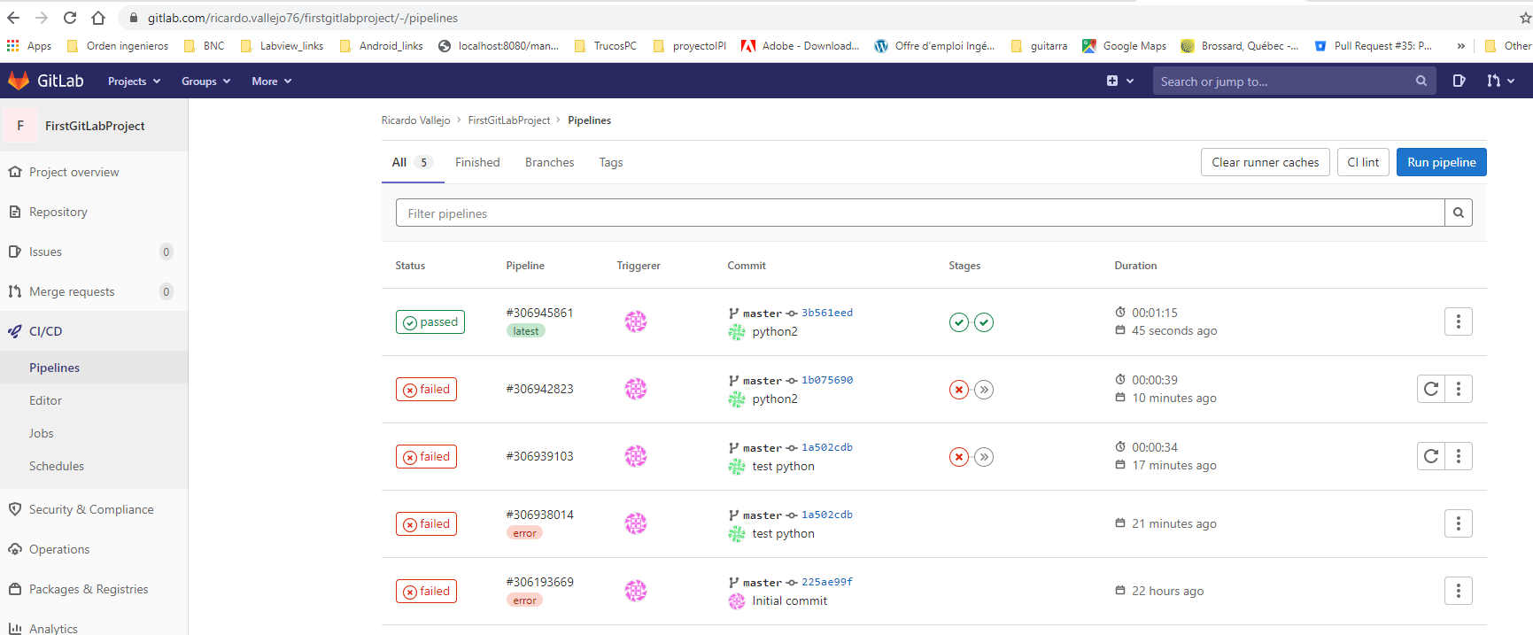

**Push image to dockerhub**

<https://www.onlinetutorialspoint.com/docker/how-to-push-docker-image-to-docker-hub.html#:~:text=1%20Create%20your%20docker%20hub%20account.%202%20Click,repositories%20list%2C%20there%20you%20can%20see%20your%20image>.

**Docker Result:**

